Question 1.

The questions on this page are based on Verhagen, M. P., de Reuver, G. A., & Bouwman, W. A. G. A. (2021). Implementing Business Models Into Operations: Impact of Business Model Implementation on Performance. IEEE Transactions on Engineering Management, 1-11

Business models (BMs) help firms to translate abstract strategic decisions into their daily operations. We adopt an empirical approach, by analyzing the results of a large-scale, representative survey among European small and medium-sized enterprises (SMEs). In line with the existing literature, the research confirms that spending time and effort on creating new BMs has a positive impact on the firm performance. This positive impact on firm performance is, in part, mediated by BM implementation (i.e., translating new BMs into operating models and enterprise architectures). This article provides empirical support for the argument that BM innovation is not just a matter of strategic thinking and experimenting with BM components and BM architecture, but that also aligning BMs to operations and enterprise architectures.

1. Formulate an **explanatory** research question that corresponds with the study. Make sure that the research question includes at least two constructs that are referred to in the abstract. Make sure the research question is not normative and not prescriptive (2 points)

Question 2

The questions on this page are based on Verhagen, M. P., de Reuver, G. A., & Bouwman, W. A. G. A. (2021). Implementing Business Models Into Operations: Impact of Business Model Implementation on Performance. IEEE Transactions on Engineering Management, 1-11

Business models (BMs) help firms to translate abstract strategic decisions into their daily operations. We adopt an empirical approach, by analyzing the results of a large-scale, representative survey among European small and medium-sized enterprises (SMEs). In line with the existing literature, the research confirms that spending time and effort on creating new BMs has a positive impact on the firm performance. This positive impact on firm performance is, in part, mediated by BM implementation (i.e., translating new BMs into operating models and enterprise architectures). This article provides empirical support for the argument that BM innovation is not just a matter of strategic thinking and experimenting with BM components and BM architecture, but that also aligning BMs to operations and enterprise architectures.

1. The authors write about two limitations of the study:   
   “Limitation 1: The results are based on a cross-sectional survey.   
   Limitation 2: Relevant control variables, like industry sector, technology or country, could not be included in the statistical analysis. This is because there was a limited sample size. Therefore, we only have controls related to size (i.e. micro, small or medium); gender of the CEO; the age of the firm; and family versus non-family business. “

For each of the limitations, state whether they relate to internal or external validity. Motivate your answer (2 points)

Question 3

The questions on this page are based on Verhagen, M. P., de Reuver, G. A., & Bouwman, W. A. G. A. (2021). Implementing Business Models Into Operations: Impact of Business Model Implementation on Performance. IEEE Transactions on Engineering Management, 1-11

Business models (BMs) help firms to translate abstract strategic decisions into their daily operations. We adopt an empirical approach, by analyzing the results of a large-scale, representative survey among European small and medium-sized enterprises (SMEs). In line with the existing literature, the research confirms that spending time and effort on creating new BMs has a positive impact on the firm performance. This positive impact on firm performance is, in part, mediated by BM implementation (i.e., translating new BMs into operating models and enterprise architectures). This article provides empirical support for the argument that BM innovation is not just a matter of strategic thinking and experimenting with BM components and BM architecture, but that also aligning BMs to operations and enterprise architectures.

1. In the paper, the authors write:

“Survey data were collected through a telephone interview, with the respondent being the manager, owner of or another core manager within the SME. “

Define the unit of observation and the unit of analysis for the study. (2 points)

Question 4.

The questions on this page are based on Verhagen, M. P., de Reuver, G. A., & Bouwman, W. A. G. A. (2021). Implementing Business Models Into Operations: Impact of Business Model Implementation on Performance. IEEE Transactions on Engineering Management, 1-11

Business models (BMs) help firms to translate abstract strategic decisions into their daily operations. We adopt an empirical approach, by analyzing the results of a large-scale, representative survey among European small and medium-sized enterprises (SMEs). In line with the existing literature, the research confirms that spending time and effort on creating new BMs has a positive impact on the firm performance. This positive impact on firm performance is, in part, mediated by BM implementation (i.e., translating new BMs into operating models and enterprise architectures). This article provides empirical support for the argument that BM innovation is not just a matter of strategic thinking and experimenting with BM components and BM architecture, but that also aligning BMs to operations and enterprise architectures.

4a. Formulate a semantic differential item to measure the construct `time spent on creating new business models’ (1 point). Please include the item and the answer categories.

4b. Suggest a way to evaluate concurrent validity (1 point)

Question 5.

The questions on this page are based on Verhagen, M. P., de Reuver, G. A., & Bouwman, W. A. G. A. (2021). Implementing Business Models Into Operations: Impact of Business Model Implementation on Performance. IEEE Transactions on Engineering Management, 1-11

Business models (BMs) help firms to translate abstract strategic decisions into their daily operations. We adopt an empirical approach, by analyzing the results of a large-scale, representative survey among European small and medium-sized enterprises (SMEs). In line with the existing literature, the research confirms that spending time and effort on creating new BMs has a positive impact on the firm performance. This positive impact on firm performance is, in part, mediated by BM implementation (i.e., translating new BMs into operating models and enterprise architectures). This article provides empirical support for the argument that BM innovation is not just a matter of strategic thinking and experimenting with BM components and BM architecture, but that also aligning BMs to operations and enterprise architectures.

5. The authors would like to assess whether the size of the SME is a moderator. Specifically, they want to compare small and medium-sized businesses. One of the authors observes that there are 1.2 million small businesses in the EU and only 200,000 medium-sized businesses. The author therefore argues that they should not use simple random sampling.

5.a. Provide an argument against the use of simple random sampling, given the considerations above (1 point)

5.b. Suggest an alternative probability sampling form that could resolve the problem (1 point)

## Question 1 (3 points, max 100 words):

Robert Yin (2018) describes four main criticisms on case study research. Mention two of these four criticisms and provide a solution to deal with both of these criticisms.

## Question 2 (3 points, max. 150 words):

Case study research often involves triangulation. List three ways in which triangulation

can be done and explain each of these ways in one sentence.

# Qualitative analysis / coding

## Question 3 (2 points, max. 60 words):

The following question is based on Susha, I., D. Rukanova, B., Gil-Garcia, R.J., Tan, Y.H., & Gasco, M. (2019). Identifying mechanisms for achieving voluntary data sharing in cross-sector partnerships for public good. In *Proceedings of the 20th Annual International Conference on Digital Government Research* (pp. 227-236).

In this study, the authors use a multiple case study approach to investigate how voluntary information sharing to create public value is achieved and what the drivers and mechanisms are to achieve public value. Their data collection included, among others, the analysis of qualitative data derived from documents and policy reports. Discuss the three main steps that Susha et. al. (2019) could have taken in their qualitative data analysis. Explain each step in one sentence.

## Question 4 (2 points, max. 20 words)

Read the following quote, which was taken from an interview with Mark Zuckerberg (November, 2021):

“There was a kernel with Instagram and with WhatsApp…where I just looked at that and I was like, okay. I think people often tend to look at these social apps and think that they’re frivolous early on. They think that these dynamics aren’t important — oh, it’s filtered photos or oh, it’s disappearing photos…

But I kind of looked at those and I was like, hey, I think that there’s something that’s important here. I think the world is probably underestimating this, and I also think that we have the skills as a company to go grow these things to reach more than a billion people around the world, because we’d done that with the core Facebook experience and I think there’s two skills there. There’s sort of the building the social experience, and then there’s the helping to ramp up a network around that, and that, I think, is also a core competence. So, I don’t know what would have happened with Instagram if we hadn’t bought it. I don’t think it’s guaranteed that it would have grown to be as big as it is.”

A researcher is interested in the motivations for Facebook to acquire Instagram and Whatsapp. She defined a coding category called ‘purchase motivations’. Based on the quote above, suggest two codes that fall within this coding category.

**Question 1 (total score 8 points)**

Researchers investigated the impact of two personality traits (Assertiveness and Politeness) on the perceived likeability a person (liking). One (alternative) hypothesis was tested:

*Hypothesis 1*: People high (vs. low) in Assertiveness are less likely to be liked.

1. On the next page, you find the JASP output of a regression analysis for this study. Do we accept or reject (alternative) *Hypothesis 1*? [open question; **1 point**]. Use the JASP regression output to motivate your answer [open question; **2 points**].
2. What is your interpretation of the intercept-only (H0) model in the regression output? Use the JASP regression output to motivate your answer [open question; **2 points**].
3. What does the VIF represent, theoretically? [open question; **1 point**]. What is your interpretation of the VIF for Assertiveness? Use the JASP regression output to motivate your answer [open question; **2 points**].

**JASP Regression Output for Question 1**

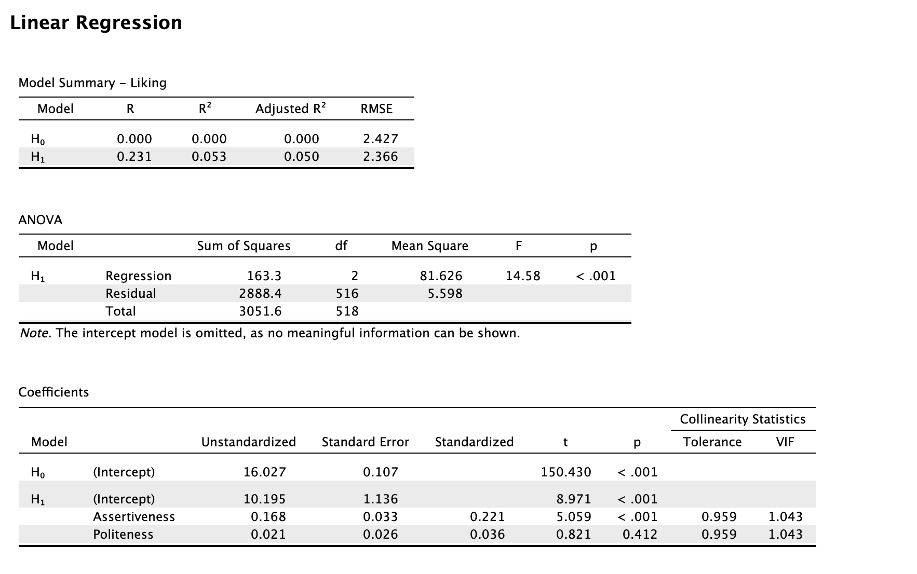

**Question 2 (total score 6 points)**

A correlation analysis of all eight dimensions of the Servant Leadership Scale (SLS) yields the following JASP output.

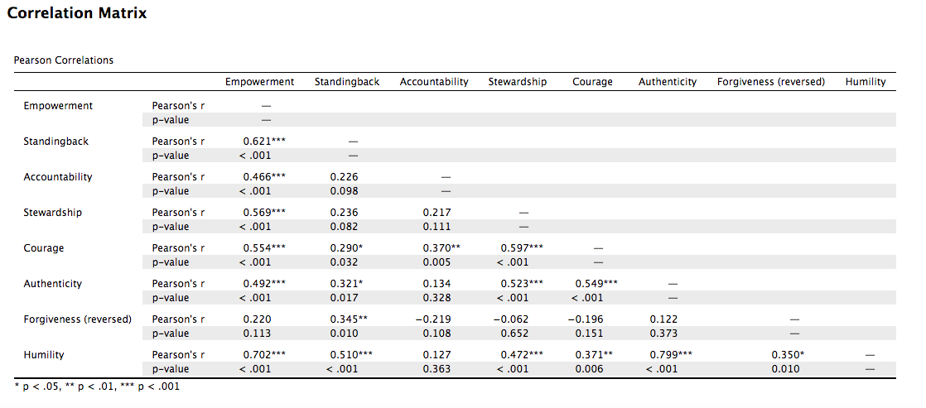

1. Please describe the theoretical link between prediction and correlation? [open question; **2 points**].
2. Please describe the theoretical link between causality and correlation? [open question; **2 points**].
3. Please, critically assess the bivariate association between the two variables Humility and Authenticity in the provided JASP output? [open question; **2 points**].

**Question 3 (total of 8 points)**

A descriptive analysis of all eight dimensions of the Servant Leadership Scale (SLS) yields the following JASP output.

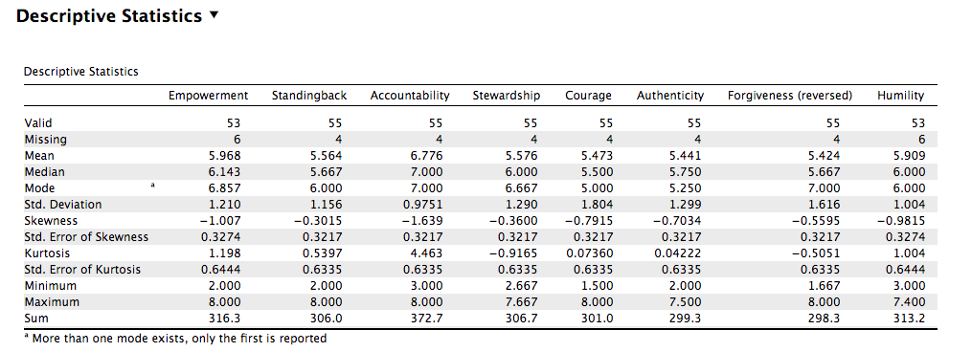

1. Which measures of central tendency are summarized in this JASP output for the SLS? [open question; **2 points**]?
2. Which of the measures of central tendency in the JASP output for the SLS is not appropriate for nominal or ordinal data? [open question; **2 points**]?
3. Which measure of central tendency can be used for nominal data, but is unreliable as a measure of central tendency? Motivate your answer [open question; **2 points**]?
4. Theoretically, what is the difference between a bar graph and a histogram? Refer to the applicable scales of measurement in your answer [open question; **2.0 points**]?

**Question 4 (total of 8 points)**

Below you find a brief description of a journal article by:

Plowright, A., Taylor, C., Davies, D., Sartori, J., Hundt, G. L., & Lilford, R. J. (2018). Formative evaluation of a training intervention for community health workers in South Africa. *PLoS ONE, 13*, e0202817.

Brief description:

“Community Health Workers (CHWs) have a crucial role in improving health in their communities and their role is being expanded in many parts of the world. However, the effectiveness of CHWs is limited by poor training and the education of CHWs has received little scientific attention. Our study was carried out in two districts in South Africa. We developed and piloted an inexpensive (two day) training intervention. Sixty-four CHWs consented to participate in the main study which measured knowledge gains using a _________________ of different testing schedules to distinguish between the effects of the intervention, testing, and any interaction between intervention and testing.”

1. The authors conducted an experiment. But, what type of research design did the authors probably use for their study? Motivate your answer [open question; **2.0 points**]?
2. Based on the description above, what is your assessment of the internal and external validity of this study? Motivate your answer [open question; **2.0 points**]?
3. Based on the description above, what was the dependent variable under study? Motivate your answer [open question; **1.0 point**]?
4. Bougie and Sekaran, in their research methods book, describe seven (7) threats to internal validity in experiments. Please mention and briefly describe at least six (6) of those threats [open question; **3.0 points**]?